1. **AEC/AGC algorithms**

The Auto Exposure Control (AEC) and Auto Gain Control (AGC) allows the image sensor to adjust the image **brightness** to a desired range by setting the proper exposure time and gain applied to the image. Besides automatic control, exposure time and gain can be set manually from external control. The related registers are listed in table 4-4.

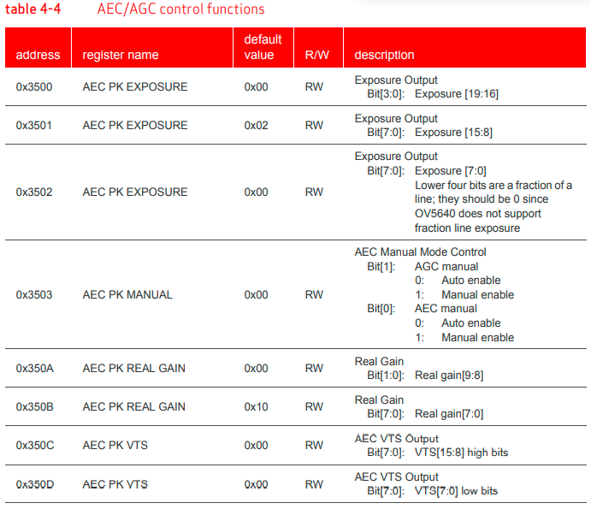

1. **Special Digital Effects (SDE)**

The Special Digital Effects (SDE) functions include **hue/saturation control, brightness, contrast**, etc. SDE also supports negative, black/white, sepia, greenish, blueish, redish, solarize and other image effects.

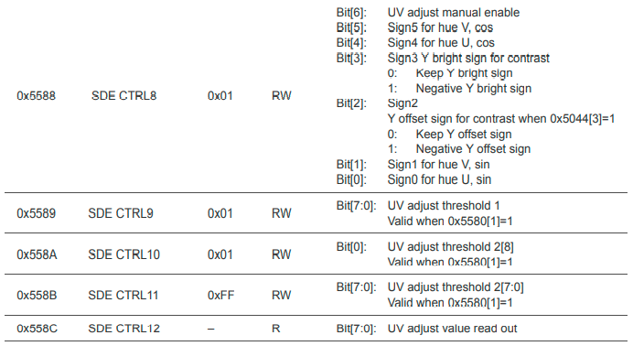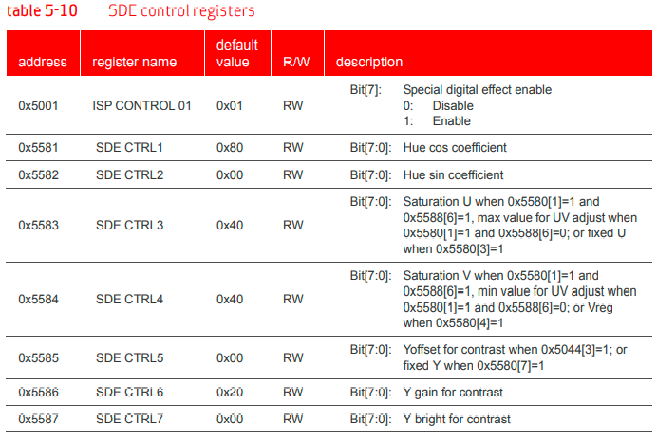

1. 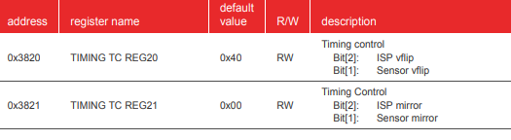**For vertical flip**
2. **For mirroring**



